OFX Service - Donation Walkthrough:

You may be more familiar with PayPal and their PayPal Xoom service but shopping around and leveraging another service like OFX may, after all be a more effective way to giving. The last time we checked we were able to save almost 9% in costs by leveraging the OFX service.

That felt like we were able to give to the refugees 9% more with the same money at hand. This is significant!

Here is the walk-through on how to transfer money to Poland with OFX:

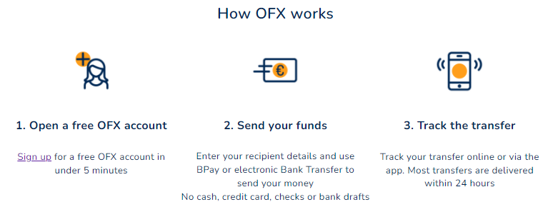
- I (Robert here) already have an account with OFX, so I cannot quite walk you through the setup, but it is simple. You can get started with the OFX here and it looks like in the below:
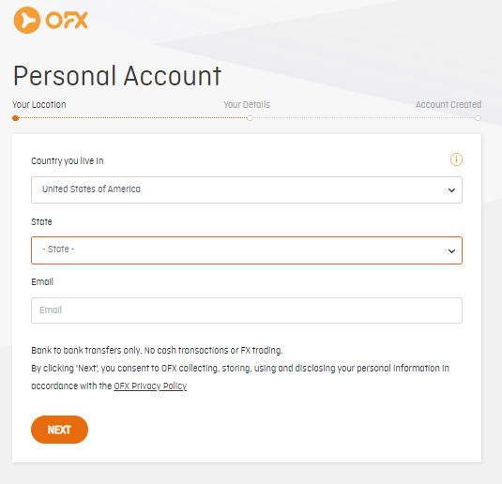

- Send your funds, which involves creating new or later selecting a recipient. Example: Create your recipient.

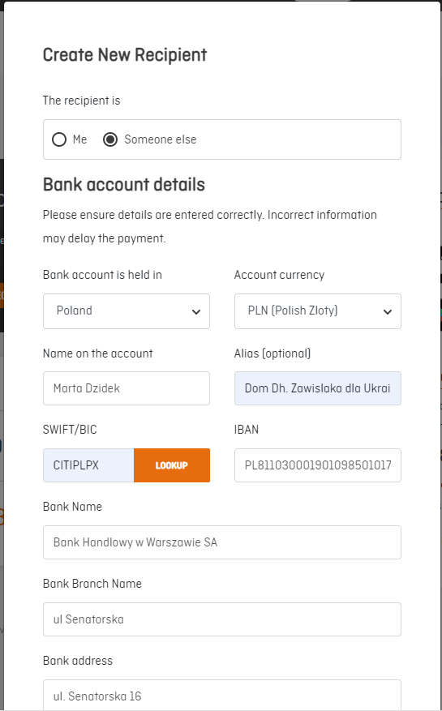

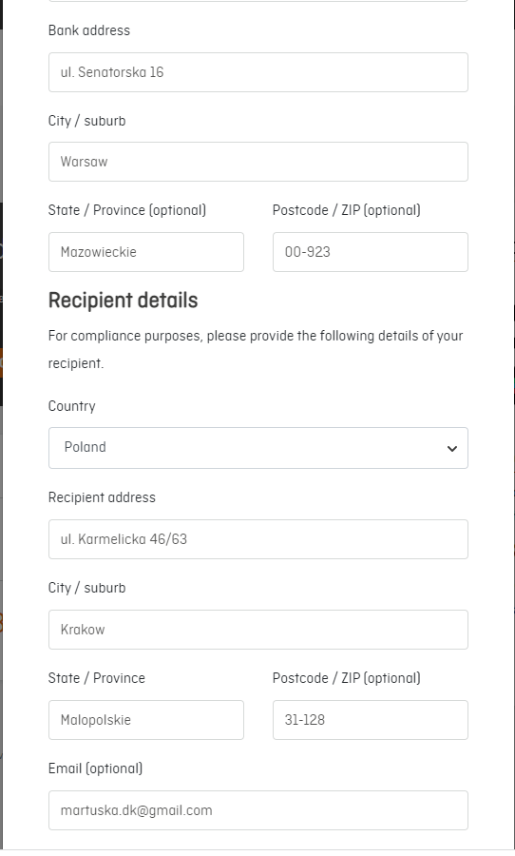
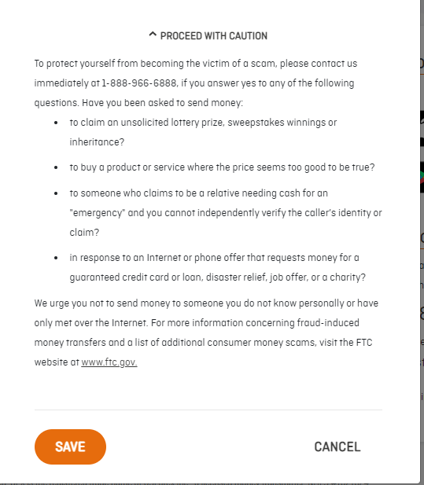
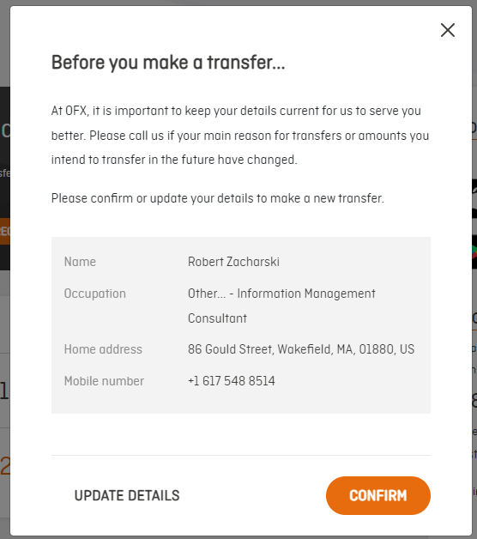

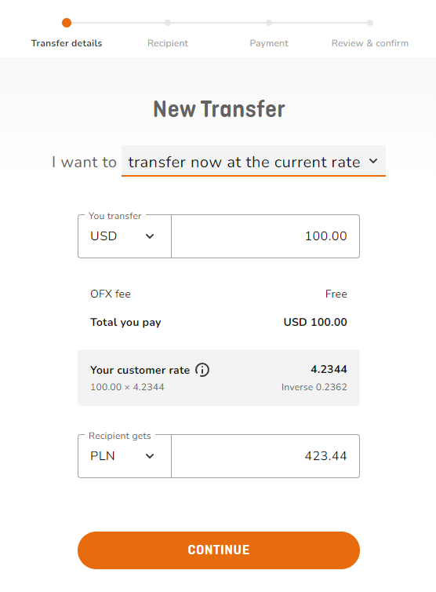
Once you set up the recipient and select the transfer details, you’ll be able to pick a recipient (I have more than one, so maybe that’s why):
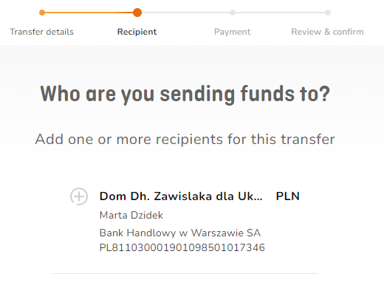
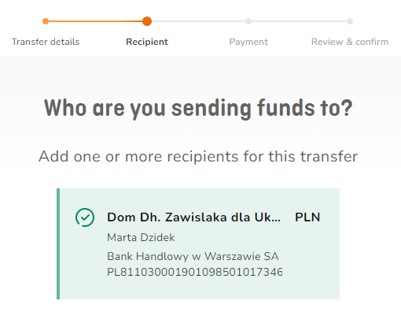

Then tell what it is for:
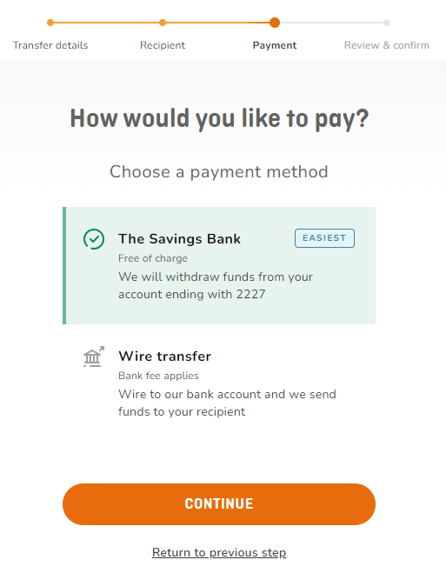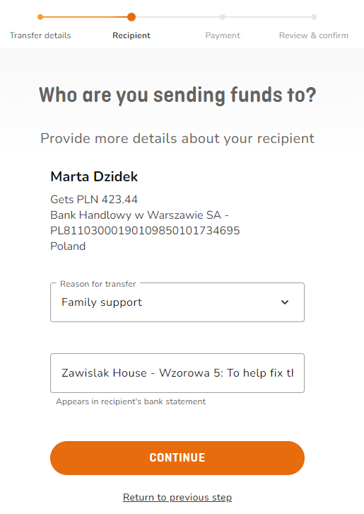

Also, how you’d like to pay. I do not remember whether I had to set up the ACH for this (takes longer), or the system simply took the bank account information. The wire transfer fees tend to be a bit higher.
Verify the details:
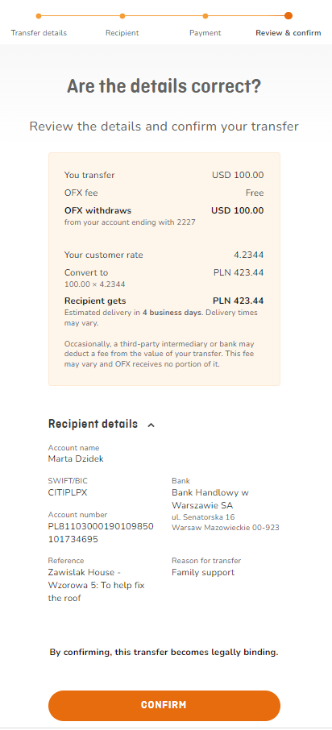

Confirm your donation, and the details will look like in the below:
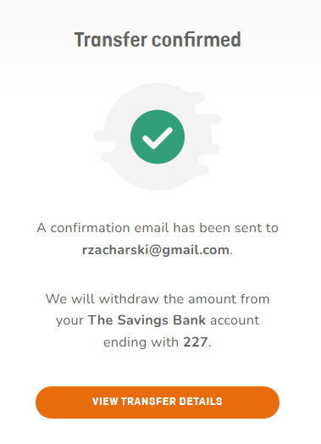

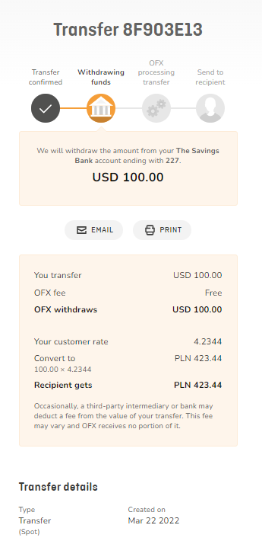

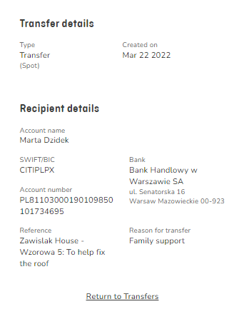

- It may take from one to four days for the money to clear the sending and the receiving banks. We have never had a problem with neither of the discussed services and we have accounts and sent monies with each of them.

Summary: This may not be fast, but it is a safe and cost-effective way of sending money internationally.

Thank you for your donation and for your support!

